**Multi Charts using QlikView**

Youth Employment Population:

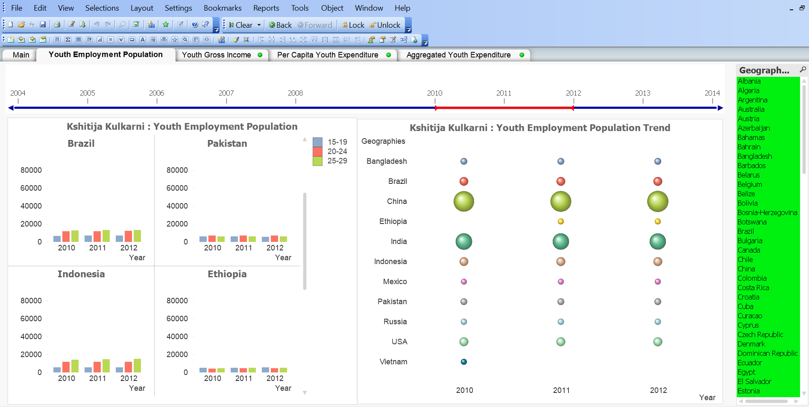

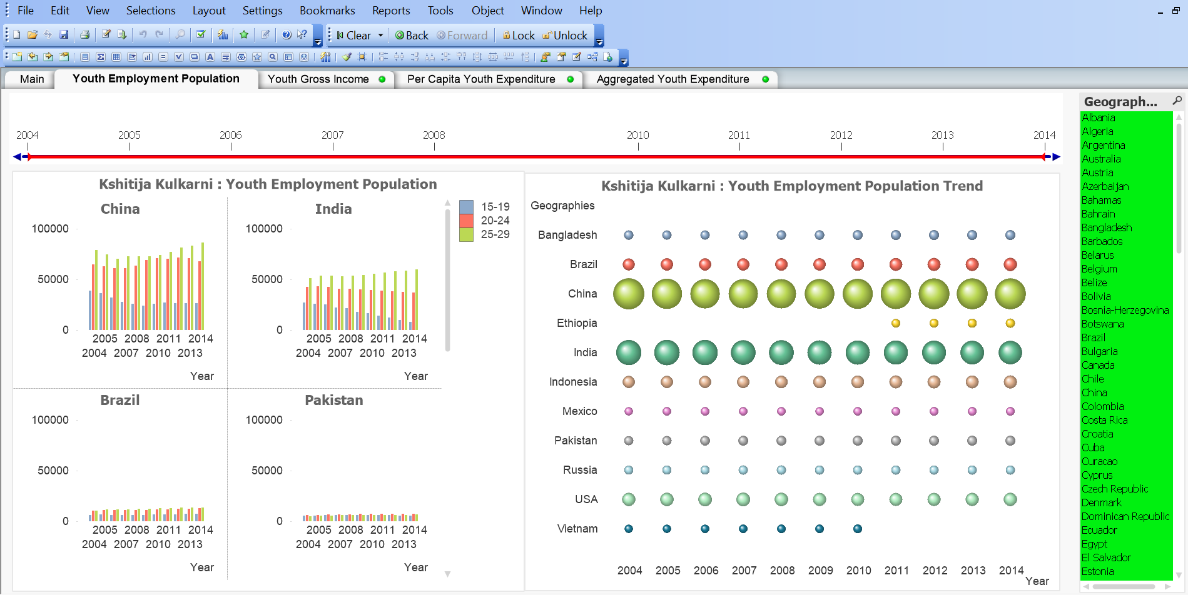

Overall, population between 15-19 years has decreased slightly, while 20-24 has remained almost constant. There is slight increase in population for age group 25-29 from 2005-2014.

For Pakistan, population in age group 15-19 decreased after 2008, while 20-24 increased slightly till 2010 and remained constant thereafter. There is a gradual increase in age group 25-29 between 2005-2014.

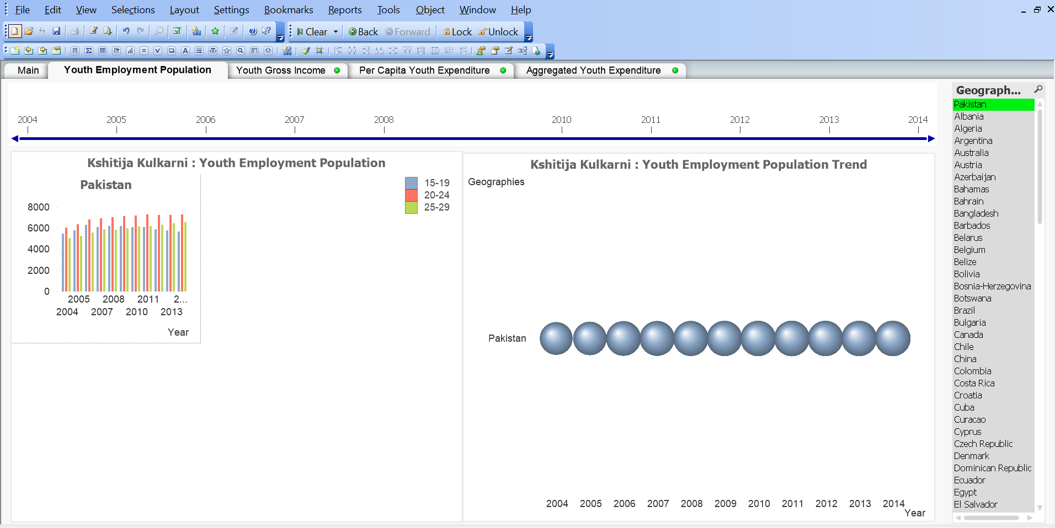

**Youth Gross Income**

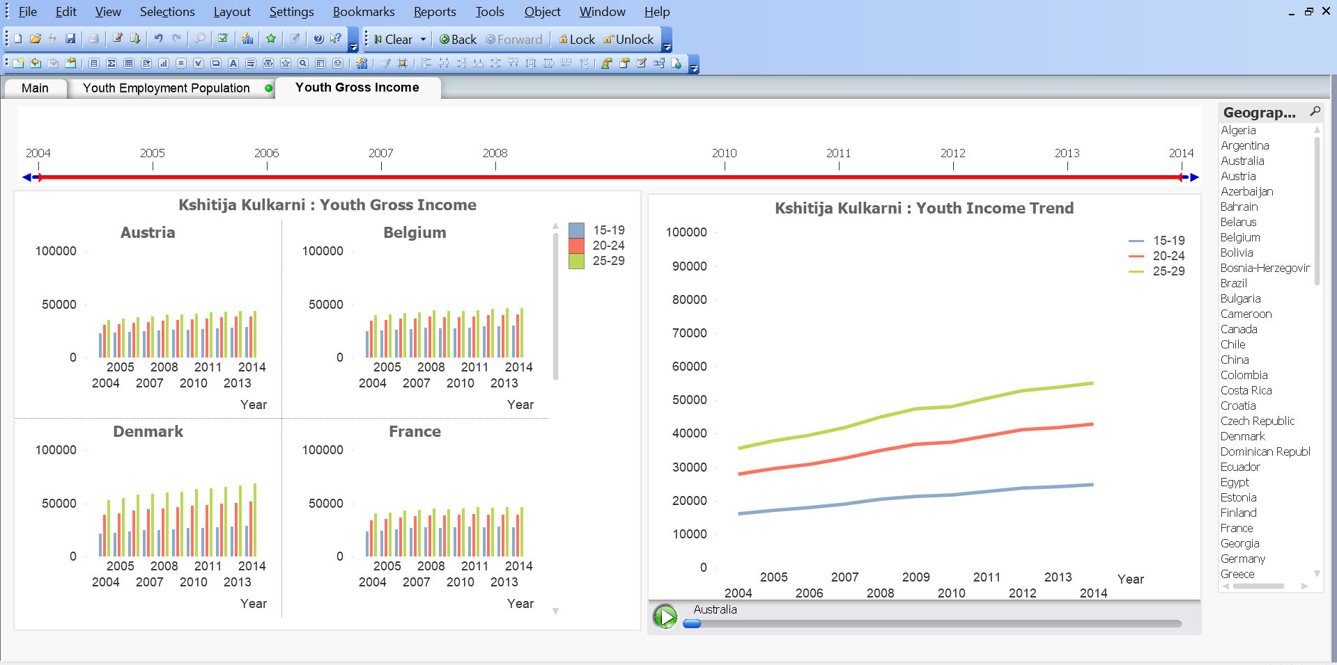

**Youth Expenditure by Age Category**

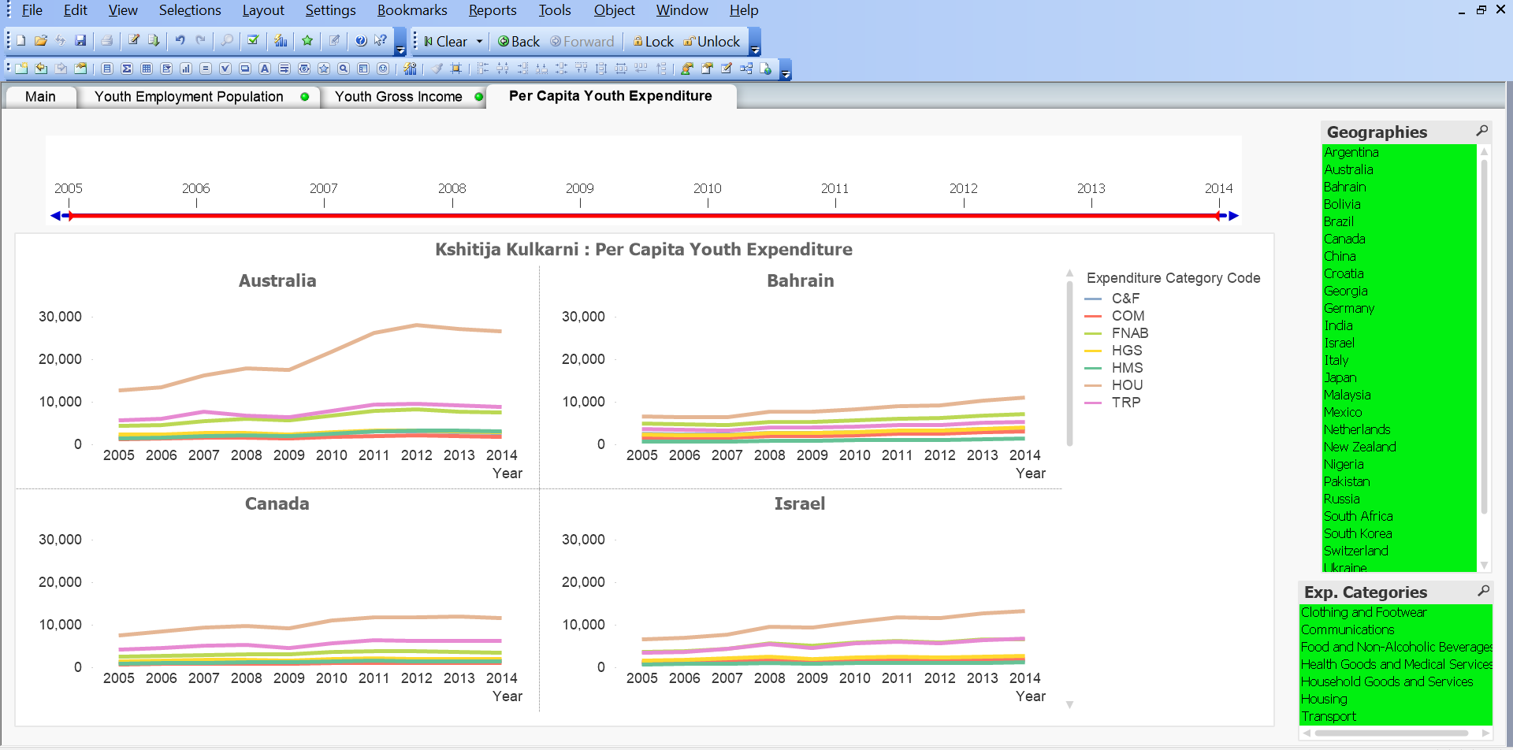

**Youth Expenditure without Age Categories**

